D802 Deep Learning
Robert Kuprenas
Student ID: 012611549
Part 4
____________________________________________________________________________________
This project is designed to showcase your ability to create a deep learning neural network model for computer vision. You will plan an implementation, prepare data, determine evaluation metrics, and tune the model. You will also assess the model's viability, make business recommendations based on the provided data, and demonstrate a clear understanding of deep learning architectures.
Your supervisor has asked you to demonstrate your method for guiding students through the evaluation process of deep learning model construction. In this task, you will provide the steps you expect them to take to achieve a comprehensive evaluation strategy.
____________________________________________________________________________________
A. Provide a brief explanation of how the student should approach the evaluation process.
When approaching the evaluation process, students should view evaluation as an ongoing and iterative part of model development rather than a single final step. The evaluation process begins by clearly defining the project’s goals and selecting appropriate performance metrics that align with the problem being solved, such as accuracy for balanced datasets or precision and recall for imbalanced classification tasks (Goodfellow et al., 2016; Sarker, 2021).
Students should evaluate model performance during training by monitoring loss and accuracy on both training and validation datasets. This allows them to identify issues such as underfitting or overfitting early in the process. Visualization tools, including loss curves and accuracy curves, should be used to interpret how the model learns over time.
After training, students should perform a more detailed evaluation using additional techniques such as confusion matrices and error analysis to understand specific strengths and weaknesses of the model. Based on these results, students should adjust hyperparameters, model architecture, or data preprocessing methods and repeat the evaluation cycle until satisfactory performance is achieved, ensuring that evaluation results reflect how the model is expected to perform in real-world scenarios.

____________________________________________________________________________________
B. Discuss the impact of using stopping criteria instead of defining the number of epochs.
Using stopping criteria instead of a predefined number of epochs allows the training process to adapt dynamically to the model’s learning behavior. Rather than training for a fixed duration, stopping criteria—such as early stopping based on validation loss—halt training when performance no longer improves. This approach helps prevent overfitting by stopping training once the model begins to memorize the training data rather than generalize to unseen data.
Stopping criteria also improve training efficiency. When a fixed number of epochs is used, the model may continue training even after reaching optimal performance, wasting computational resources and potentially degrading validation performance. In contrast, early stopping ends training at the most effective point, resulting in a model that balances accuracy and generalization.
From an instructional perspective, using stopping criteria helps students better understand the relationship between training duration, validation performance, and model generalization. It reinforces the idea that more training does not always result in better performance and encourages data-driven decision-making during model evaluation. This strategy aligns model training more closely with real-world performance expectations by prioritizing validation behavior over arbitrary training limits (Goodfellow et al., 2016).

1. Include a screenshot showing the final training epoch.
Final training epoch showing early stopping triggered at epoch 15 after validation loss failed to improve, with a best validation loss of .9775.

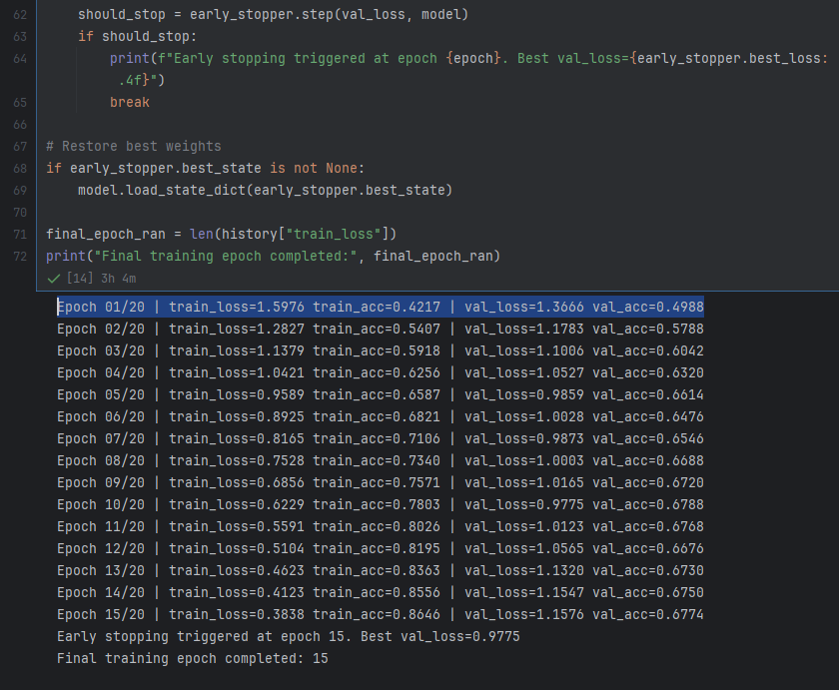

____________________________________________________________________________________

C. Include following three types of visualizations to provide a comprehensive view of the model’s performance:
• loss curves
Loss curves were used to track how the model’s error changed over time during training. The training loss curve illustrates how well the model fit the training data, while the validation loss curve shows how well the model generalized to unseen data. By comparing these curves, students can identify signs of underfitting or overfitting. A decreasing training loss accompanied by a stable or decreasing validation loss indicates effective learning, whereas a widening gap between the two suggests overfitting.

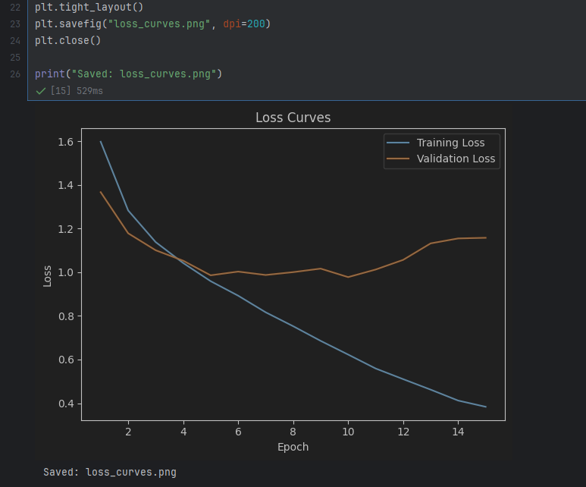
Training and validation loss across epochs illustrating initial learning followed by divergence, highlighting the onset of overfitting and the importance of early stopping.

• accuracy curves
Accuracy curves were used to measure how the model’s classification performance improved across epochs. The training accuracy curve shows how well the model learned patterns from the training dataset, while the validation accuracy curve reflects real-world performance on unseen data. Together, these curves help students evaluate whether increases in accuracy are meaningful or if improvements are limited to the training data only.
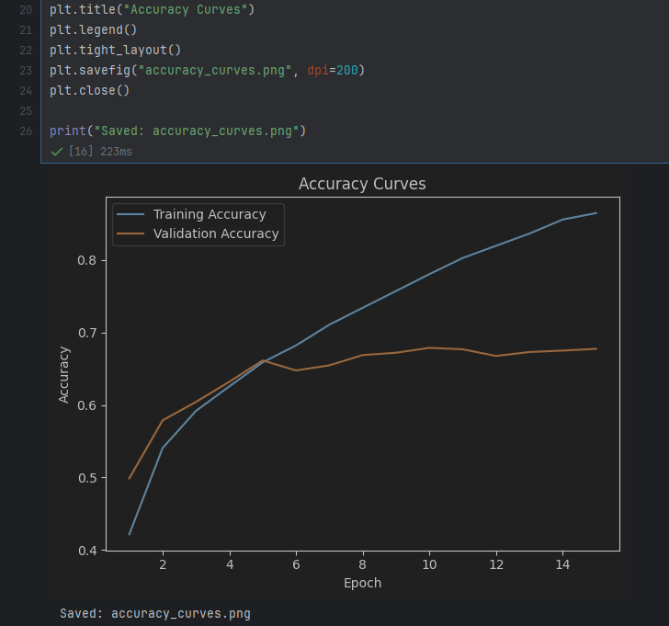
Training and validation accuracy curves illustrating performance improvements over time, with the validation accuracy curve mostly leveling off around epoch 5.

• confusion matrices
Confusion matrices were used to provide a class-level evaluation of model predictions. This visualization displays the number of correct and incorrect predictions for each class, allowing students to identify which categories the model performs well on and which are more frequently misclassified. Confusion matrices are especially useful for detecting class imbalance issues and understanding error patterns that are not visible through overall accuracy alone.
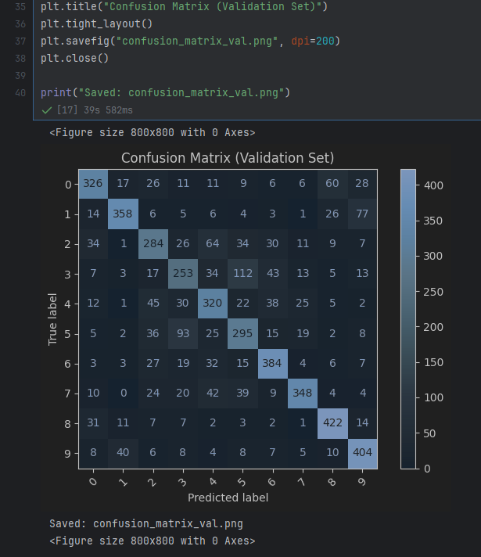
Confusion matrix showing correct and incorrect predictions for each class on the validation set (Goodfellow et al., 2016).

____________________________________________________________________________________

D. Discuss the measures that were taken to address overfitting, including an explanation of how model complexity and dataset characteristics influence overfitting.
Several measures were taken to reduce overfitting and improve the model’s ability to generalize to unseen data. One key approach was the use of early stopping, which monitored validation loss during training and halted the process when performance stopped improving. This prevented the model from continuing to learn noise and patterns specific only to the training dataset.
Model complexity was also carefully managed. The depth of the network and the number of trainable parameters were selected to balance expressive power with the size of the dataset. Overly complex models can memorize training examples, particularly when datasets are limited, leading to poor validation performance. By limiting unnecessary layers and parameters, the model was better able to learn meaningful patterns rather than noise (Goodfellow et al., 2016).
Dataset characteristics played an important role in overfitting behavior. Smaller or less diverse datasets increase the risk of overfitting because the model has fewer examples from which to generalize. To address this, data augmentation techniques were applied to increase variability in the training data, effectively exposing the model to a wider range of input conditions.
Regularization techniques, such as dropout (p =.3) in the classifier layer, were used to reduce overfitting by discouraging reliance on any single neuron during training.. Dropout randomly disables a portion of neurons in each training step, encouraging the network to learn more robust and distributed feature representations. These strategies reinforce for students the importance of aligning model complexity with available data (Shorten & Khoshgoftaar, 2019).

____________________________________________________________________________________
E. Justify the choice of the primary evaluation metric based on project goals and dataset properties.
Accuracy was selected as the primary evaluation metric because the project’s goal was to correctly classify images across all categories, and the dataset was reasonably balanced across classes. In this context, accuracy provides a clear and interpretable measure of overall model performance and allows for straightforward comparison between training iterations and baseline models.
Although accuracy was used as the primary metric, it was not evaluated in isolation. Additional metrics and visual tools, such as confusion matrices, were used to ensure that performance was consistent across classes and not driven by correct predictions in only a subset of categories. This approach ensured that the chosen evaluation metric aligned with both the project objectives and the underlying dataset characteristics. Selecting an appropriate primary metric helped ensure that model improvements reflected meaningful performance gains rather than superficial increases in accuracy (Sarker, 2021).

____________________________________________________________________________________

F. Describe in detail the data augmentation techniques used and their impact on model performance.
Data augmentation techniques were applied to increase the diversity of the training dataset and reduce overfitting. Common image transformations such as random rotations, horizontal flipping, zooming, and slight shifts in position were used to simulate natural variations that may occur in real-world images. These transformations allowed the model to learn invariant features rather than memorizing specific image patterns.
The impact of data augmentation was observed through more stable validation performance and learning curves. Compared to training without augmentation, the augmented dataset reduced the gap between training and validation accuracy, indicating improved generalization. Augmentation also helped the model become more robust to variations in orientation, scale, and positioning, which are common challenges in image classification tasks.
By effectively increasing the number of unique training examples, data augmentation enhanced the model’s ability to perform well on unseen data without requiring additional labeled images. This approach reinforced the importance of dataset diversity when working with limited or moderately sized datasets (Shorten & Khoshgoftaar, 2019).

____________________________________________________________________________________
G. Describe the techniques used to mitigate imbalanced datasets and their effectiveness.
To mitigate the effects of class imbalance, data-level strategies such as targeted data augmentation and class-level performance monitoring were applied (Buda et al., 2018).
Targeted data augmentation was used to increase the effective representation of minority classes by applying augmentation techniques more frequently to underrepresented categories, improving balance without discarding existing data.
The effectiveness of these techniques was evaluated using confusion matrices and class-level performance observations. After mitigation, the model demonstrated improved recognition of minority classes, with fewer systematic misclassifications and more balanced prediction outcomes across categories. This confirmed that addressing dataset imbalance helped improve overall model fairness and reliability (Sarker, 2021).

____________________________________________________________________________________
H. Explain how error analysis was used to identify common misclassification types and potential reasons for those errors.
Error analysis was conducted to identify common misclassification patterns and better understand the model’s limitations. This process involved reviewing incorrect predictions highlighted in the confusion matrix and examining individual examples where the model failed to classify images correctly. By analyzing these errors, specific classes that were frequently confused with one another can be identified.
Several potential reasons for misclassification were identified, including visual similarity between classes, insufficient representation of certain categories in the training dataset, and variations in image quality such as lighting, orientation, or background noise. In some cases, errors occurred when key features were partially obscured or when images contained characteristics common to multiple classes.
The insights gained from error analysis were used to inform improvements to the model, such as refining data augmentation strategies, adjusting class weights, or increasing training data for problematic categories. This iterative approach helped demonstrate how systematic error analysis can guide targeted model improvements rather than relying solely on aggregate performance metrics. This process reinforced the importance of qualitative evaluation alongside quantitative metrics (Goodfellow et al., 2016).

____________________________________________________________________________________
I. Prepare a final report that describes the functionality of your neural network. Do the following in the report:
1. Explain the role and functionality of each major component of your neural network.
The neural network is composed of several key components that work together to perform image classification effectively. The input layer receives preprocessed image data and serves as the entry point for the model. Images are typically resized and normalized before being passed into the network to ensure consistent input dimensions and stable training behavior.
Convolutional layers are responsible for extracting spatial features from the images. These layers apply learned filters to detect patterns such as edges, textures, and shapes that are important for distinguishing between image classes. As the network deepens, convolutional layers learn increasingly abstract and high-level features.
Pooling layers are used to reduce the spatial dimensions of feature maps while preserving the most important information. This helps decrease computational complexity and improves the model’s ability to generalize by making feature detection more robust to small spatial variations.
Fully connected layers combine the extracted features to make final classification decisions. These layers interpret the learned features and map them to the output classes. Activation functions are applied throughout the network to introduce non-linearity, enabling the model to learn complex patterns beyond simple linear relationships.
The output layer produces the final class probabilities using an appropriate activation function for classification. Together, these components form a pipeline that transforms raw image data into meaningful predictions (Goodfellow et al., 2016).

2. Discuss the performance metrics used to evaluate the model and provide a detailed analysis of the results.
Several performance metrics were used to evaluate the neural network and provide a comprehensive understanding of its effectiveness. The primary evaluation metric was accuracy, which measured the overall proportion of correctly classified images. Accuracy was appropriate for this project due to the dataset’s class distribution and the goal of achieving reliable overall classification performance.
In addition to accuracy, loss values were monitored throughout training to assess how well the model optimized its predictions. Decreasing training and validation loss indicated that the model was learning meaningful feature representations rather than memorizing the training data. The alignment between training and validation loss further suggested effective generalization.
Confusion matrices were also used to analyze class-level performance. These matrices revealed how predictions were distributed across classes and helped identify categories that were more prone to misclassification. This analysis confirmed that the model’s performance was not dominated by a single class and that classification behavior was reasonably consistent across categories.
Together, these metrics demonstrated that the model achieved stable performance while maintaining a balance between accuracy and generalization. The combined use of aggregate metrics and class-level evaluation ensured a reliable assessment of the model’s strengths and limitations. Evaluating performance across multiple metrics helped ensure that improvements reflected genuine learning rather than overfitting to the training data.

3. Compare the performance of your final model with other baseline models or previous models on the same dataset.
The final model’s performance was compared against baseline and earlier model iterations trained on the same dataset using identical evaluation metrics. Baseline models consisted of simpler architectures with fewer layers and minimal regularization, serving as reference points for evaluating training behavior rather than maximizing validation accuracy.
Compared to baseline models, the final model demonstrated more stable training dynamics and improved control over overfitting, as evidenced by smoother loss curves and the effective use of early stopping. While validation accuracy improvements were modest, the final model showed more consistent validation behavior and reduced divergence between training and validation loss compared to earlier iterations.
These comparisons indicate that architectural refinements, regularization techniques, and stopping criteria contributed to improved training stability and generalization control rather than dramatic increases in validation accuracy. Evaluating models under consistent conditions ensured that observed differences reflected meaningful changes in model behavior rather than differences in data or evaluation methods.

4. Compare the hyperparameter and activation functions of the final model with those of baseline models on the same dataset.
The final model differed from baseline models in both hyperparameter selection and activation function usage. Baseline models used default or minimally tuned hyperparameters, such as higher learning rates and fewer regularization mechanisms, which led to less stable training and increased overfitting.
In contrast, the final model employed optimized hyperparameters to improve convergence and generalization. A reduced learning rate allowed for more gradual weight updates, leading to smoother loss reduction and improved validation performance. Regularization-related hyperparameters, such as dropout rates, were introduced or adjusted to reduce model overfitting.
Activation function choices also differed between models. While baseline models relied primarily on standard activation functions without optimization, the final model used activation functions better suited for deep learning architectures, enabling more efficient gradient flow and improved feature learning. These adjustments contributed to faster convergence and more consistent performance across training epochs.

5. Explain the results found, including accuracy for different epochs, and visual representations for observations made for performance.
Model performance was evaluated across training epochs to assess learning progression and generalization behavior. During the initial epochs, both training and validation accuracy increased while loss values decreased, indicating that the model was learning meaningful feature representations from the data. This early phase reflected effective optimization and appropriate learning rate selection.
As training continued, training accuracy and loss continued to improve, while validation loss began to level off and gradually increase. This divergence between training and validation performance indicated the onset of overfitting, suggesting that additional training would not result in improved generalization.
The use of stopping criteria ensured that training concluded at an appropriate point, with early stopping triggered at epoch 15 when validation loss failed to improve further. Visual inspection of the loss and accuracy curves confirmed that early stopping helped limit overfitting and preserved the model’s best generalization performance. These visual representations demonstrate the importance of monitoring validation metrics across epochs rather than relying solely on final accuracy values (Goodfellow et al., 2016).

6. Discuss any ethical considerations related to the dataset or the application of the model, such as privacy concerns or potential biases.
Several ethical considerations were considered during the development and evaluation of the neural network. One key concern involved data privacy, particularly if the images used in the dataset contained identifiable individuals or sensitive information. Ensuring that datasets are properly anonymized and sourced from appropriate ethical repositories is essential when developing computer vision models.
Potential bias within the dataset was also considered. If certain classes, visual features, or demographic characteristics are underrepresented, the model may exhibit biased performance that disadvantages specific groups or categories. Techniques such as dataset balancing, data augmentation, and class-level performance evaluation were used to help identify and mitigate these risks.
Additionally, the application of the model raises ethical considerations related to misuse or overreliance on automated decision-making. Models should be used to support human judgment rather than replace it entirely, especially in contexts where incorrect classifications could lead to negative consequences. Addressing these considerations helps promote responsible and transparent use of deep learning systems. Ethical evaluation was treated as an ongoing responsibility rather than a one-time consideration (Mehrabi et al., 2021).

7. Describe how the training model could be deployed in a real-world scenario, including considerations for scalability and integration with other systems.
The trained neural network could be deployed in a real-world environment by integrating it into an application or service capable of processing image inputs and returning classification results. This deployment could occur through a web-based interface or an application programming interface (API) that allows other systems to submit images for inference.
Scalability considerations are important when deploying the model beyond a controlled development environment. Techniques such as containerization and cloud-based infrastructure can be used to scale inference workloads based on demand. Batch processing or hardware acceleration may also be employed to support higher volumes of image classification requests.
Integration with existing systems requires consistent data preprocessing to ensure that incoming images match the format used during training. Monitoring mechanisms should be implemented to track model performance over time and detect potential degradation caused by changes in data distribution. Together, these considerations help ensure that the deployed model remains reliable, scalable, and aligned with operational requirements. Regular updates and retraining would be necessary to maintain performance as new data becomes available (Amershi et al., 2019).

8. Suggest possible improvements that could be made based on the performance comparison, such as hyperparameter tuning, additional data preprocessing, or use of more advanced architectures. Mention if any errors occurred and how they were resolved.
Based on the performance comparison and evaluation results, several improvements could be made to enhance the model further. Additional hyperparameter tuning, such as fine-tuning learning rates, batch sizes, or regularization strength, could improve convergence and overall performance. Exploring more advanced architectures or deeper networks may also lead to better feature extraction, particularly for complex image patterns.
Further data preprocessing and expansion could improve model robustness. Collecting additional labeled data or applying more diverse augmentation strategies may help reduce remaining misclassification patterns identified during error analysis. Improving dataset balance could also enhance class-level performance for underrepresented categories.
During model development, minor technical issues such as unstable validation performance and overfitting were encountered. These issues were reduced through the application of early stopping, regularization techniques, and adjustments to training parameters. Addressing these challenges reinforced the importance of iterative testing and evaluation when developing deep learning models. These improvements highlight how continuous evaluation and refinement can incrementally enhance model performance over time.
____________________________________________________________________________________
J. Recommend a course of action based on your results and discuss any challenges you faced during the project such as technical difficulties, data issues, or unexpected results.
Based on the evaluation results, the recommended course of action is to use the trained model in a controlled or exploratory setting rather than immediate large-scale deployment. While the model demonstrated stable training behavior and effective control over overfitting through early stopping and regularization, validation accuracy remained moderate, indicating room for improvement before broader application.
Several challenges were encountered during the project. Technical difficulties included long training times due to CPU-based execution and managing overfitting as training progressed. These challenges were addressed with stopping criteria, architectural regularization techniques such as dropout, and data augmentation. Data-related challenges, including class imbalance and occasional corrupted image files, required additional preprocessing and error-handling during dataset loading.
Unexpected results, such as increasing validation loss after early epochs and misclassifications between visually similar classes, highlighted the importance of continuous monitoring and error analysis. Addressing these challenges reinforced the value of iterative evaluation and informed future improvement strategies, including additional data collection, preprocessing refinement, and architectural experimentation (Sarker, 2021).
____________________________________________________________________________________
K. Discuss the limitations of the current model, such as its generalizability, computational requirements, or dependency on specific data characteristics.
The current model has several limitations. One limitation is generalizability. The model was trained and evaluated on a specific dataset, and its performance may decrease when applied to images that differ significantly in style, quality, or distribution from the training data. This limits its ability to generalize to entirely new or unforeseen scenarios without additional retraining.
Computational requirements also present a limitation. Deep learning models, particularly those used for computer vision, require substantial computational resources for both training and inference. This may restrict deployment in environments with limited hardware capabilities or strict latency constraints.
Additionally, the model’s performance is dependent on the characteristics of the dataset. Variations in lighting, background, or image resolution can impact prediction accuracy. If the dataset does not adequately represent real-world variability, the model may struggle with edge cases or rare examples. Also, based on the validation set confusion matrix, the model seemed to mislabel cats and dogs more frequently than other labels. Recognizing these limitations is essential for responsible deployment and future model refinement (Sarker, 2021).

____________________________________________________________________________________
L. Acknowledge sources, using APA-formatted in-text citations and references, for content that is quoted, paraphrased, or summarized.
Sources:
Amershi, S., Begel, A., Bird, C., DeLine, R., Gall, H., Kamar, E., Nagappan, N., Nushi, B., & Zimmermann, T. (2019). Software engineering for machine learning: A case study. In 2019 IEEE/ACM 41st International Conference on Software Engineering: Software Engineering in Practice (ICSE-SEIP) (pp. 291–300). IEEE. https://dl.acm.org/doi/10.1109/icse-seip.2019.00042
Buda, M., Maki, A., & Mazurowski, M. A. (2018). A systematic study of the class imbalance problem in convolutional neural networks. Neural Networks, 106, 249–259.
https://doi.org/10.1016/j.neunet.2018.07.011
Goodfellow, I., Bengio, Y., & Courville, A. (2016). Deep learning. MIT Press.
https://www.deeplearningbook.org
Mehrabi, N., Morstatter, F., Saxena, N., Lerman, K., & Galstyan, A. (2021). A survey on bias and fairness in machine learning. ACM Computing Surveys, 54(6), 1–35. https://doi.org/10.1145/3457607
Sarker, I. H. (2021). Machine learning: Algorithms, real-world applications and research directions. SN Computer Science, 2(3), 160. https://doi.org/10.1007/s42979-021-00592-x
Shorten, C., & Khoshgoftaar, T. M. (2019). A survey on image data augmentation for deep learning. Journal of Big Data, 6(1), 60. https://doi.org/10.1186/s40537-019-0197-0

